SYSC 4907 Final Report
Video Store System
3/12/2012

Group 14
Group Members
Kelechi Nnorom 100783816
Kerrie Newton 100748041
Aniekan Akai 100751295
Mostafa Hussen 100661280

Supervisor Dr Yvan Labiche
Carleton University
TABLE OF CONTENTS

1.1 Engineering professionalism 5
1.2 Project Management 5
1.3 Individual Contributions 6
1.4 Report Contributions 6
1.5 Requirement Elicitation: 10
1.6 Requirement Specification: 13
1.7 Use Case Descriptions 17
Database Server 35
1.8 Entity Relationship Design 37
1.9 Relational SQL Database Definition 37
1.10 Database Schema 37
1.11 PHP 39
Appendix IComplete use case descriptions 50
Appendix IIDefinitions, acronyms, abbreviations 71
Appendix IIICode Excerpts 72
III.1 Code excerpt for login validation 72
III.2 Code excerpt for register 76
III.3 Code excerpt for forgot password 81
III.4 Code excerpt for search 84

LIST OF FIGURES

Figure 1 Customer's view Use Case Diagram 15
Figure 2 Employee's view Use Case Diagram 16
Figure 3 Shows the Entity Class diagram. 21
Figure 4: Class diagram of Boundary(Interfaces) classes(Including GUI classes) 22
Figure 5 System Component Diagram 24
Figure 6 Rent item (a) and Return item (b) interfaces 31
Figure 7 Show the Database Schema used by the Video Store System 38
Figure 8 Login 40

Abstract
This report describes our group's implementation of a video store management system. We used the Entity-Relationship model to design a database that will store and organize the store's data. We have created the database using SQL and populated it with some sample data. The system can keep track of video, games, stock levels, rentals, reservations, customers, members, employees, store locations and the relationships between them. Using Java, Netbeans IDE and JDBC, we have created an Internet-based graphical user interface that allows members and employees of the video store to access the system remotely.
Introduction
This document discusses the result of the 4th Year project entitled “A Video Store System” during the 2011/2012 academic year at Carleton University. The team consisted of Kelechi Nnorom, Kerrie Newton, Aniekan Akai and Mostafa Hussen, supervised by Dr. Yvan Labiche. The objective of this project was to design and implement a Video Store System using proper software engineering methodology. The project was divided into three different components, which were the video store employee interface, the video store administrator interface and an online store for clients.
The report is divided into sections: In section we provide a brief discussion about the project.
The Engineering Project – discussion about engineering professionalism, project management and individual project/report contributions
Background- an overview of the Video Store System
Software Architecture- discusses how we approached the project and which design pattern was used
Requirement Elicitation – The report will cover the functional and non-functional requirements, the scope, actors (i.e. who is using the system) and the use cases, which explain the functionalities of the system and what is the system should do.
System Analysis - It discusses the entity, boundary and the control objects using class diagrams and sequence diagrams.
Data Dictionary- It explains the entity, control and boundary classes, including their attribute, pre and post condition and the definitions of each operation.
Implementation – how the database was designed and implemented and the use of PHP to embed dynamic text
Website

The Engineering Project
This chapter is an overview of the engineering project and discusses the various professional techniques that were used during the course of the project. The third part of this chapter discusses how proper management skills were utilized to manage the project. The last section indicates the individual work performed by the team members both in the project along with the final report.

Engineering professionalism
Through the academic year our group exemplified a professional demeanour. We attended the scheduled meetings punctually with prepared material. In addition all major project deadlines were met. The group members also acted in a professional manner when dealing with each other during the course of the project.

Project Management
Project management is a very important factor in the success of any project. The first order of business was to devise a detailed schedule to ensure all project deliverables are met. We divided the project into components and estimated the timeline for each component. This allowed each member to be prepared, resulting in effective work being performed.
In addition, we set up bi-weekly (weekly in some instances) meetings with our supervisor Dr. Yvan Labiche, where we discussed completed work and upcoming tasks.

Individual Contributions
Team Member | Contribution
All | - Requirement Elicitation  - Analysis and Design
Aniekan Akai | - GUI Implementation  - Boundary class implementation  - JDBC Implementation
Mostafa Hussen | - Entity classes Implementation  - Control Classes implementation
Kerrie Newton | - Database implementation  - PHP implementation
Kelechi Nnorom | - Website Design  - Component Diagram

Report Contributions
Team Member | Contribution
All | - Introduction  - The Engineering Project  - Future Work  - Lessons Learned  Conclusion
Aniekan Akai | - System Analysis  - GUI implementation  - Boundary classes  - Software Architecture
Mostafa Hussen | - Video Store System  - Requirement Elicitation  - Data Dictionary
Kerrie Newton | - Software Architecture  - Database Server  - Relational Database Schema  - Entity Relationship Design
Kelechi Nnorom | - Website  - Component Diagram
Video Store System
The Video Store system to be designed herein called VSS is to be used in a video store that rents and sells video copies and games. Both games and videos have a title and the store may have many copies of a given game or video.
The VSS only allows members of the store to rent copies of videos and games, however anyone may purchase a copy of a game or video. VSS members have a membership card which has a barcode and is used when trying to rent a video or game.
Video store employees may create new memberships. Employees may utilize the VSS to help customers search for a copy of a video or game. The VSS is also used to add and remove copies of videos or games, reserve copies and to sell copies of videos or games. When a customer rents an item their membership card and the item are scanned using the barcode scanner. This allows the employee to retrieve customer account information and information on the copy such as whether it is a game or video, how much it rents for, what would be the return date, the selling price and if it has been reserved.
In addition to employees, there are administrators who are able to renew or suspend privileges, add or remove titles from the database, and update account information.
When members return items, an employee scans the items to clear it from the member’s account. At the same time, the item is checked to see if it is overdue.
Members returning items late will incur a late fee for every additional day past the scheduled return date. The VSS checks daily for overdue items and updates the corresponding members account to ban them from renting additional items. The VSS also automatically emails an overdue notice to overdue customers reminding them that the item they rented is overdue and requesting them to return it.
Members can reserve an item for which there is currently no copy in stock. A reservation can be held for a week after the item copy becomes available. When the item becomes available, if the member’s account information contains an email, the email system would automatically notify the member of the availability of the item. After a week of being on hold, the item is available for rent or purchase.
There is also an online aspect to the VSS where customers can search for both games and videos. Members can log in to access their account details where they will be able to see current and past rentals along with making reservations.
Software Architecture
This software is a standalone program; it is implemented as a client-side application only. This software will require a designated database server to operate. This software is designed to be efficient, error-free, and user-friendly. The architecture pattern used is Centralized Client-Server Architecture.
We chose the Centralized Client-Server architecture because it was well suited for distributed systems with large amounts of data and many clients [10] . In the case of the VSS we will have to store and handle data in the form of item information, customer information and reservations. We also considered that the information would not be static but ever changing as the VSS can be deployed across multiple clients (stores) and online. Client- Server architecture allows the data to be stored on a central server, in our case a web server [10]. This allows the data to be accessed via the web from any client either in-store or online. Furthermore this architecture is used because we do not require an algorithm or calculation on the background with comparison to Distributed Functionality architecture.
Centralized Client-Server architecture was a better choice for our application over Distributed Client-Server architecture since the data was all stored in one place. If we used the Distributed architecture we would have been faced with the problem of data consistency. We would have to ensure that the same data is updated, saved and available on every system (server).

An alternative we considered was Repository architecture which is well-suited for an application with constantly changing complex data-processing tasks [10]. The downside is that the central repository becomes a performance bottleneck and the coupling between repository and subsystems is high, so it makes it hard to change the repository. Centralized Client-Server does not have the issue of coupling and performance bottlenecks.

This software is also designed to achieve the goal of modularity. In order to support object-oriented design, JAVA (an object-oriented language) is used as our core language; and to ensure the independence of the classes. Each class is carefully designed to support a group of data that is only relevant to specific functionalities. For example the item class contains data that represents an item (such as video or game copies) and this data would be relevant for functionalities that deal primarily with items (such as rent and purchase). However the item object would not be designed for member oriented functionalities such as creating an account, although it would be designed in a manner that allows it to be used in these functionalities.
We have designed the system such that we have separated different aspects of it. We have abstracted the system to have an in-store system, the online system (website) and a server side where the database lies. The in-store system was then implemented and separated such that, there is a GUI part and interfaces, stored information section and the controllers for certain groups of functionalities. This was done for ease of use, and ease of debugging.
For the server side, we utilized a Database Driven Website were all the information was stored in a MySQL database. To connect in-store system to the server side we used Java Database Connectivity (JDBC). The website was dynamically driven by PHP scripts to perform all necessary actions for example search and user login as defined in the customer view use case descriptions,

AT THIS STAGE OF THE INTRODUCTION TO SECTION 5 IT WOULD BE NICE TO TELL THE READER WHAT S/HE CAN EXPECT. PLEASE HAVE SENTENCES SUCH AS: IN SECTIO 5.1. WE … IN SECTION 5.2 WE …

Requirement Elicitation:
The first step of the lifecycle is very important as it defines the system from the customer’s perspective. The problem statement is first described in English so that it can be read and understood by the customer, and is then modeled more formally into UML. The formal version can be used to communicate the problem to developers without any of the uncertainties that a spoken language can sometimes introduce.

-
Functions, specifically the functionlities described in the requirements—In our case, these include managing members, titles and reservations. Handling rental and return of rental items. Sending automatic reminders and notifications by e-mail.
-
Application domain, specifically requirements that are specific to the domain of stores—In our case, these include, managing of members, titles and reservations.

Technology, the system should be able to run onany PC regardless of the operating system.

Similarly, non-functional requirements, which are restrictions on the system that limits our choices for constructing a solution, can be related to different qualities of the software end-product

NonFunctional Requirement | Metric | Expected Metric Value
Usability | Number of user error | 3 error per attempt
Availability | Probability of failure | 0.01%
Security | Backup time | Every 24 hours
Performance | User response time | 0.2 seconds
Reliability | Down Time | 1 hour in every 3 months
Table 3: Non functional requirements metrics and the expected metric value.

- Usability: Customers or members should be able to rent, reserve, or search items with ease using the user interface. The GUI is designed to be user friendly and intuitive.
- Maintainability: The product can be corrected from defects, meet new requirements, make future maintenance easier, or cope with a changed environment (e.g., from Windows to Linux or to Mac).
- Security: The system maintains high level security through its database, and authentication of the user during the transaction process. The website utilizes a PHP login script to act as a content management system, thus restricting access to different sections and functions of the website.
- Reusability: it means majority of the objects can be reused for various types of applications. The system is currently designed for use with a Video Store but with some modification the system should be able to de deployed for other uses like a Library Management system.
- Reliability: the ability of a system or component to perform its required functions under stated conditions for a specified period of time. We want the system to work as specified. The Video Store System should continue to perform correctly under different scenarios and circumstances. The system should always meet the specified functionalities.
-

Requirement Specification:
Given the functional and non-functional requirement discussed above, we further specified the software requirements under the form of actors, use cases and a use case diagram.
We identified the following actors:
- A Customer is any person, who is a non-member. They can create an account and search for items. Customer can also purchase items in-store and online.
A Member is any person who has paid membership fees and has a valid membership card. Members can reserve a video title that is currently not available for rent, resulting in pending reservations. They can reserve items, return items, pay overdue, purchase items, cancel reservation or rent items both in-store and online .

- An Employee is a person employed by the store who can handles account memberships, item reservation, item purchases, item returns, item updates and queries, and item overdue. They can assist customers in purchasing and renting item copies.
- An Administrator is an employee of the store who can update membership information, modify video and game titles, bar/reinstate member privileges
- The DBMS is a management system that stores all item information such as titles, price and number of copies along with the member and employee information
- The Calendar and Clock System provides system information such as time and date and is used to trigger the automatic email notification of overdue rentals. –
The Email System: sends emails to members notifying them of the status of their rentals and reservations or to remind them of overdue payments. The email system is external to the system.
- The Printer: prints receipts and memberships card for member transactions
- The Bar code reader: used to scan the barcode on membership cards, video and game copies.
- The Delivery system: Handles item delivery to a specific destination. The delivery system is external to the Video Store System.
The use cases and their relationships are specified under the form of several use case diagrams: for illustration purposes we split the use case diagrams into two parts, focussing on the use cases triggered by a customer of the video store system (Figure 1) and the use cases triggered by the video store employee (Figure 2).
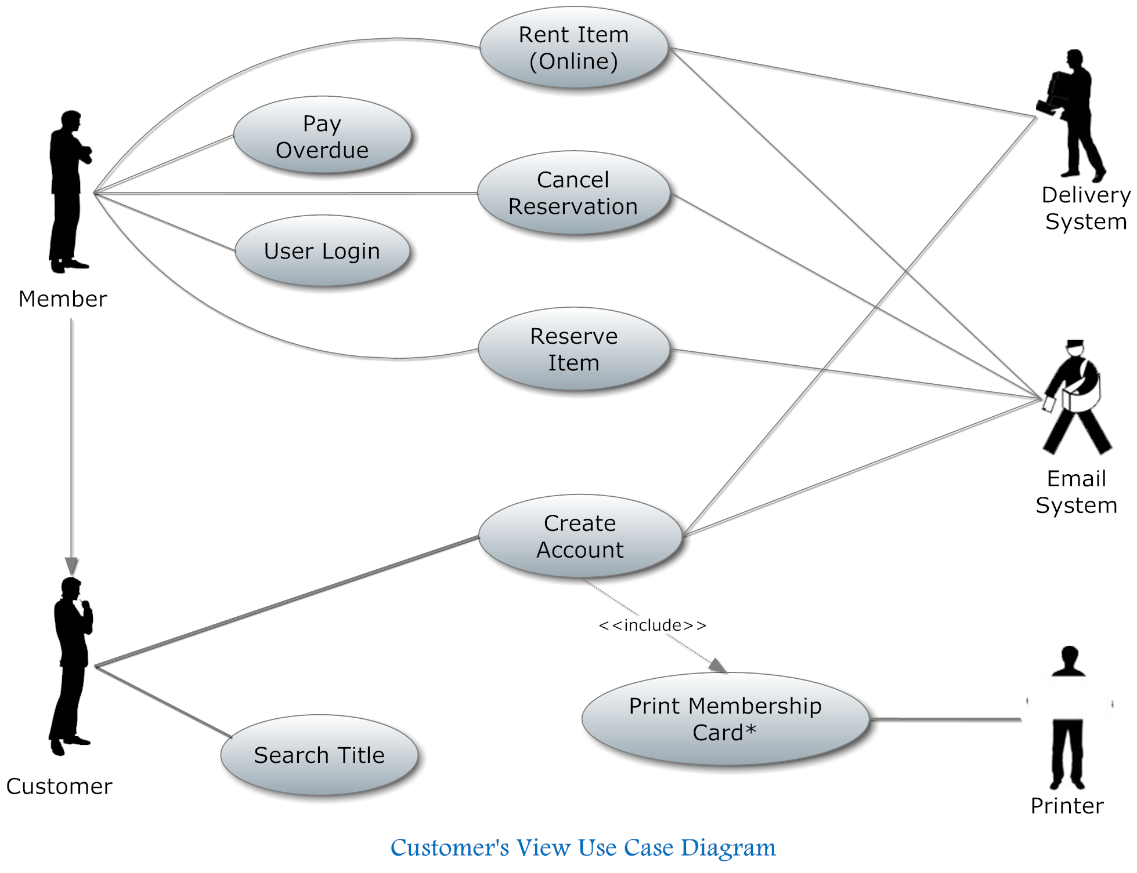
Figure 1 Customer's view Use Case Diagram
In Figure 1 we show a use case diagram for the customer’s view of the system. Here we see a customer can also be a member. Members are allowed to rent and reserve items and pay fees, while customers can only search for a title and create an account.
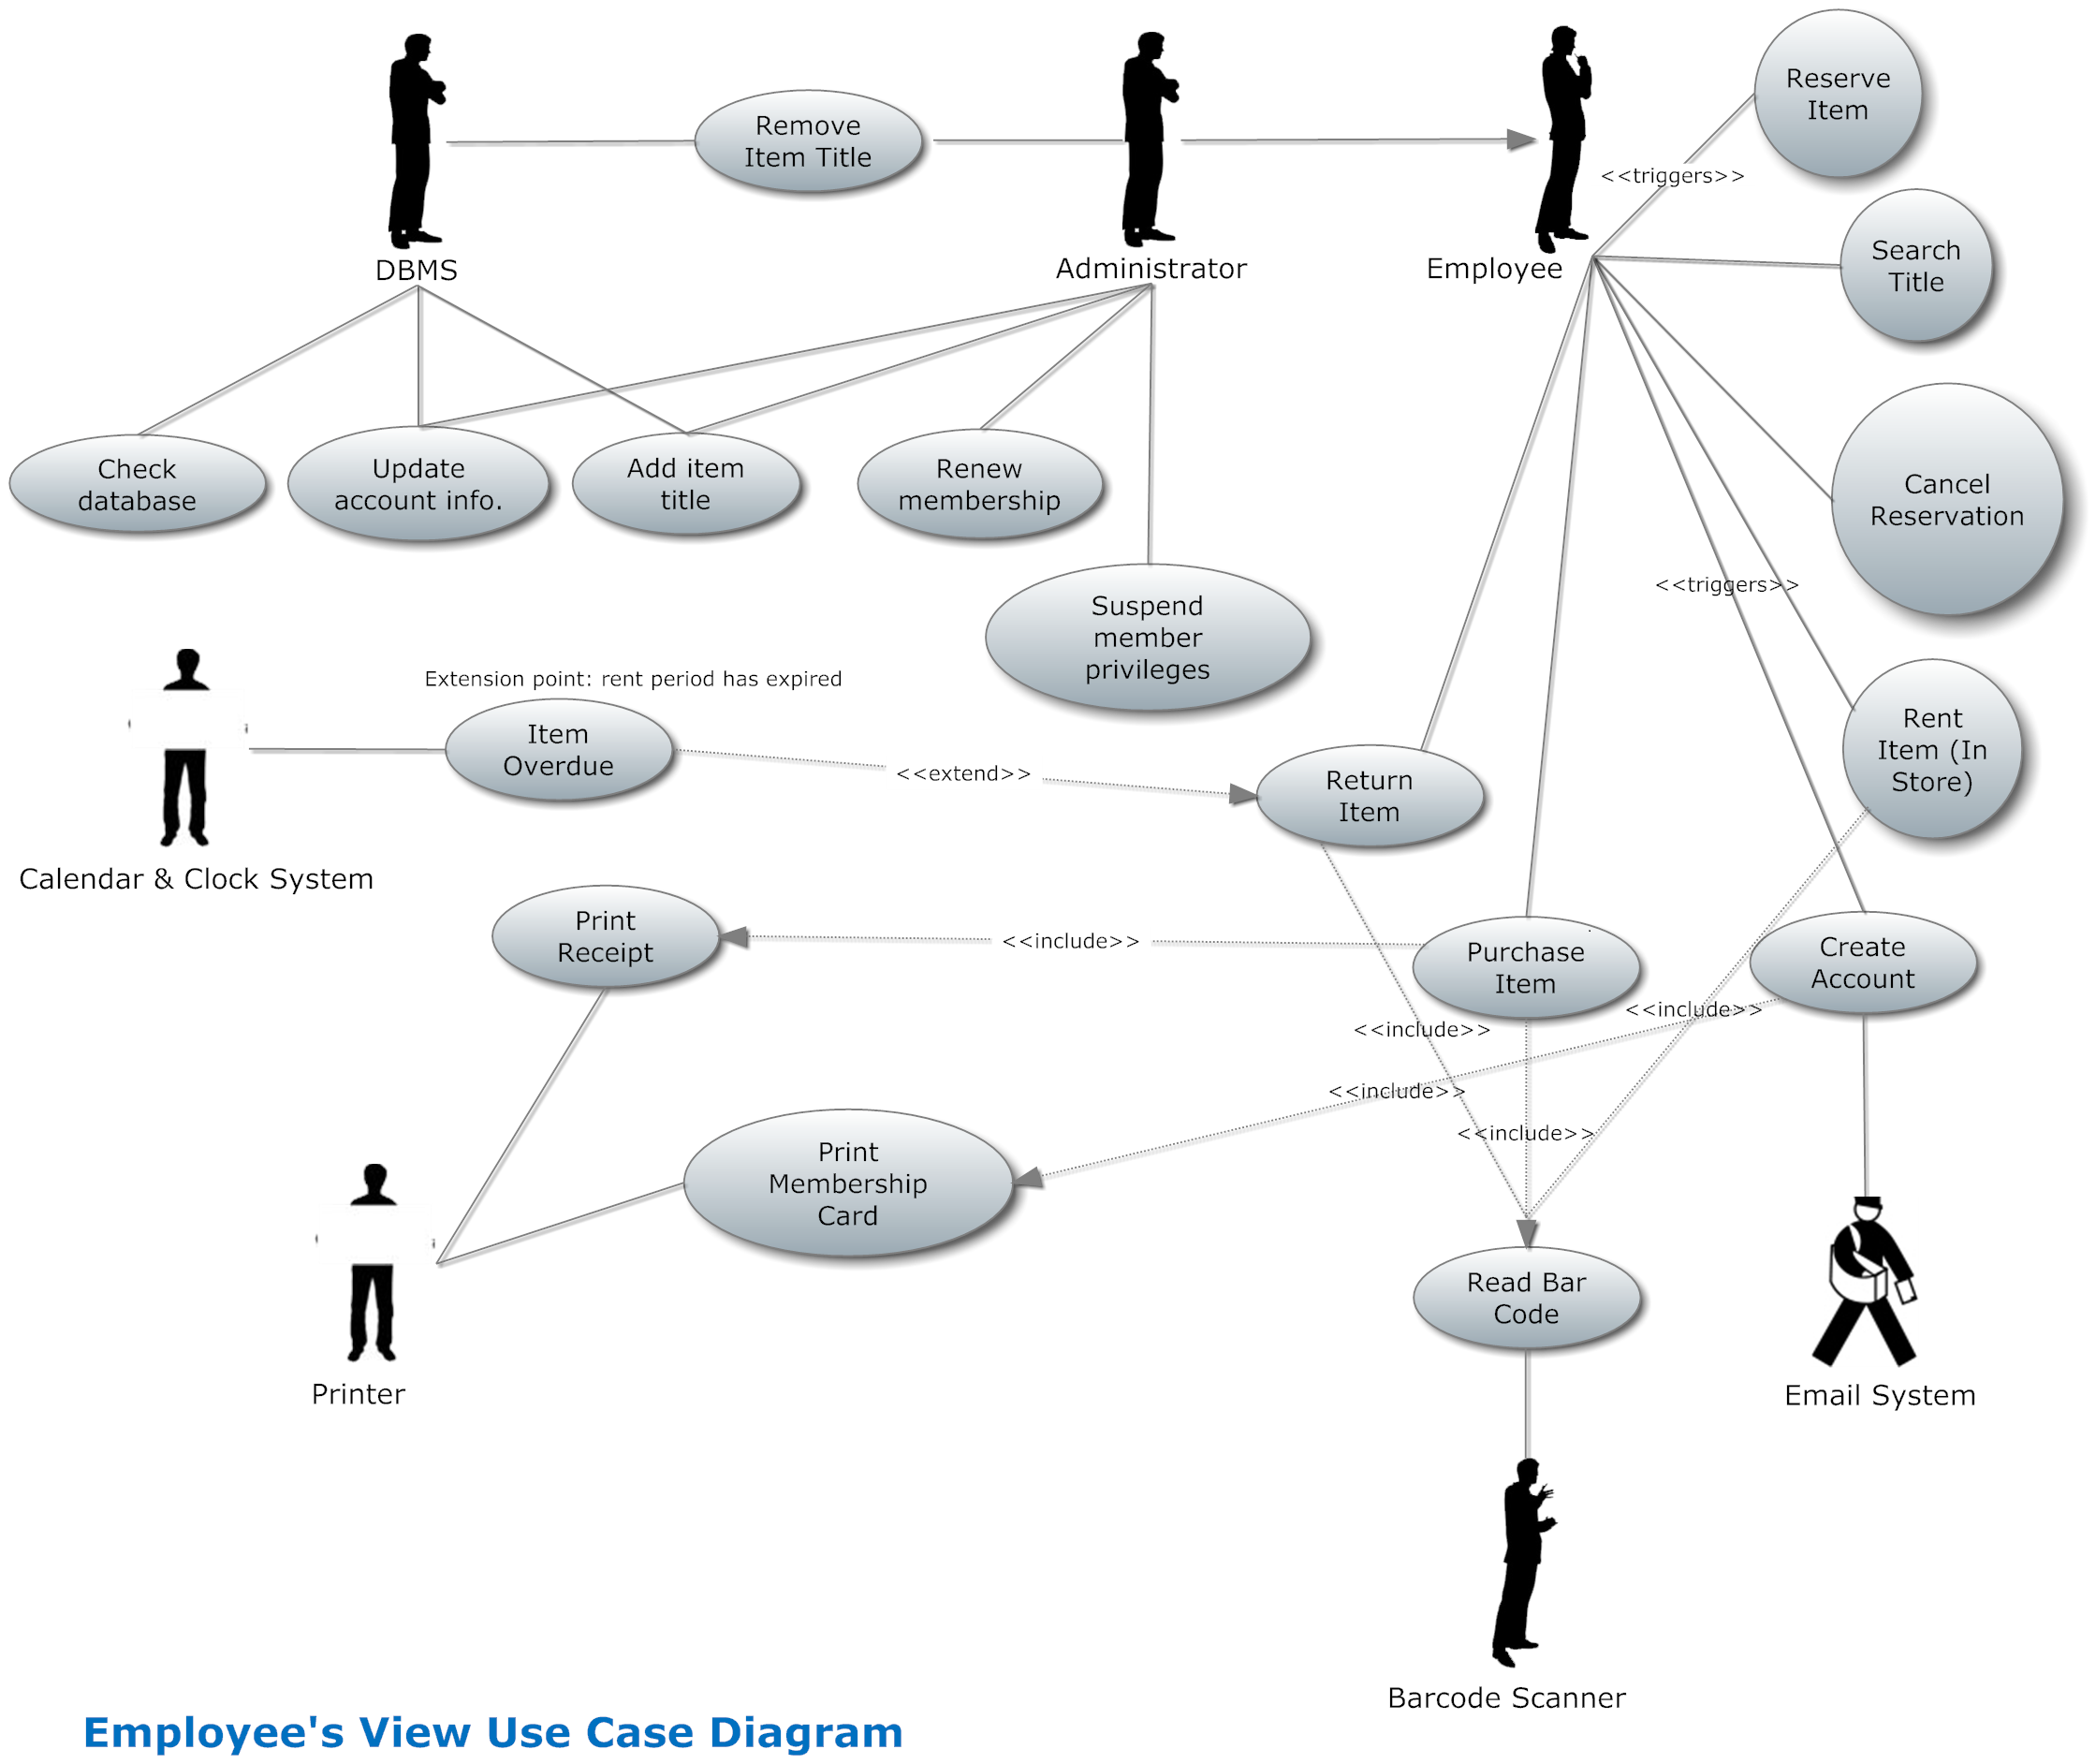
Figure 2 Employee's view Use Case Diagram
In Figure 2 we show a use case diagram for the employee’s view. There we have an administrator who is a special type of employee. In addition to account creation and maintenance, rentals and reservations, the administrator can remove an item title from the database, renew membership and suspend member privileges.

Use Case Descriptions

In this part of the report we are going to describe some of use case in detail. All these use cases are included in the appendix section of this report.

Rent Item (in Store)
The use case “Rent Item” in Figure 2 is initiated by the member when he wants to rent a movie or a game from the store. The member chooses one or more movies for to rent and asks the clerk for an availability check of the titles chosen. The clerk uses a bar code reader to retrieve information about particular titles and he uses a card reader to retrieve members information. After that the screen will show how many copies are left in the store and the possibility to rent titles. The Employee presses “rent a movie” button and the movie copy is marked in the system as being rented for the default period. This use has a high level of complexity compared to other use case, because its one of the main functionality of the system.

Primary actor: Employee
Supporting actor: Barcode scanner
Objects: Member, Rental Item
Functions: Renting an item.

Reserve Item

A member wants to rent a copy but the copy of a movie or a game is not available.
The Employee searches for a particular copy in the system and the screen showing all dates when the copy will be available appears. After the date which suits the member best is chosen, the clerk presses a “make reservation” button and the reservation for the title is made. The member is informed by the clerk what day the copy will be ready for rent in the store. This use has a high level of complexity compared to other use case, because its one of the main functionality of the system.

Primary Actor: Employee
Supporting actor: None
Objects: Reservation, member, title
Functions: Create reservation

Purchase item (in Store):

The use case “Purchase item” in Figure 2 is initiated by the member when he wants to buy a movie or a game from the store. The member or the customer chooses one or more movies for to buy. The Employee uses a bar code reader to retrieve information about particular titles and he uses a card reader to retrieve members’ information for a member. After that the screen will show how many copies are left in the store and the possibility to rent titles. The Employee selects “Buy a movie” button and the movie copy is marked in the system as being purchased. This use has a high level of complexity compared to other use case, because its one of the main functionality of the system.

Primary actor: Employee
Supporting actor: Barcode scanner
Objects: Member, Customer, Item
Functions: Purchasing an item.

System Analysis
The Video Store system was developed such that the user, whether a customer at home or an employee in the store, can perform the actions he or she wants to perform with ease. The system has therefore two sides: User direct access to the system (implemented as a Website) and In- store direct system access by an employee.
There is a side where the user directly performs the main functionalities of the system such as Rent Video/Game, Buy Video/Game, Reserve Video/Game, Create Account, Edit Account Information, and Search Video/Games available. In the other hand, the in store system is for the employee use, where the employee performs these main functionalities on behalf of the customer and when and administrator logs in, more can be done, such as Adding Items to the store database, Removing Items from the store database, Suspending a member’s privileges and Renewing memberships. The in store system is implemented in Java/JDBC.

Before the implementation and after the requirement analysis, i.e. defining use cases and modelling the use case diagram, we as a group came together to analyse the system, defining the entity, boundary and control classes needed to implement the system. We have created two class diagrams one which shows the connections between the different classes and another showing the relationships between the control classes and the entity classes. The Entity classes are those that are used to store information that would be used in the future. Entity classes are usually the data being stored in the database, as seen in this case, where we have databases information for games, videos, member accounts, employees and reservations. 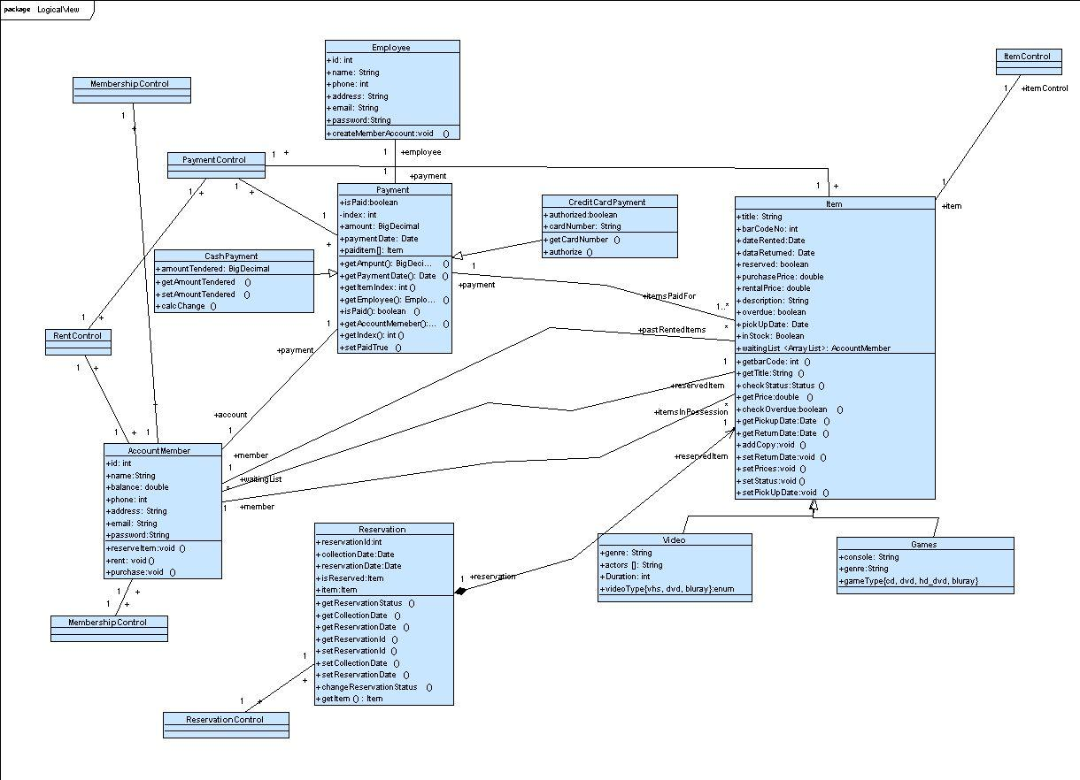
Figure 3 Shows the Entity Class diagram.
The following class diagram (Error: Reference source not found) shows the boundary/interface classes. These classes show the interface between the employee and the system (GUI), and interface between external devices and the system (BarcodeScannerInterface and PrinterInterface).
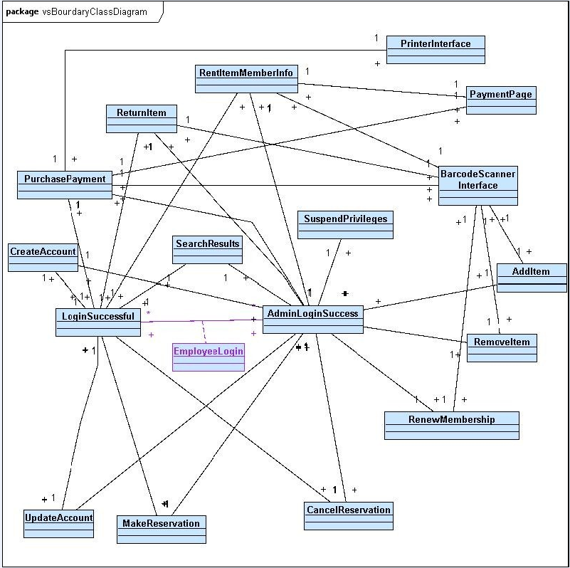
Figure 4: Class diagram of Boundary(Interfaces) classes(Including GUI classes)

Component Architecture and Design
The component diagram's main purpose is to show the structural relationships between the components of a system. Component diagrams allow an architect to verify that a system's required functionality is being implemented by components, thus ensuring that the eventual system will be acceptable.
For the component architecture we decided to use a traditional generic layered architecture however, this pattern will only have three layers as seen at Figure 3. We decided that a function layer was not necessary because we design all our function as operations and place them in the model classes. The top layer will represent the interface layer which contains subsystems such as, a user interface, a bar code reader interface, card reader interface and the system interface for emails. The second layer is the model layer together with functions which contains the model from the problem domain. The addition of functions to the model layer will give the system functionality and allow the actors (users) in the system to use the system. The lowest layer is the technical platform layer, which contains all technical elements, mainly the SQL server. We will also enforce the closed strict variation of the layered architecture, which ensures that the layer above will only have access to the layer immediately below. This will also make it easier to maintain the system as well as making error corrections. It therefore also means that, the layer above will have to make calls via operations to the layer below to provide functionality to the system.

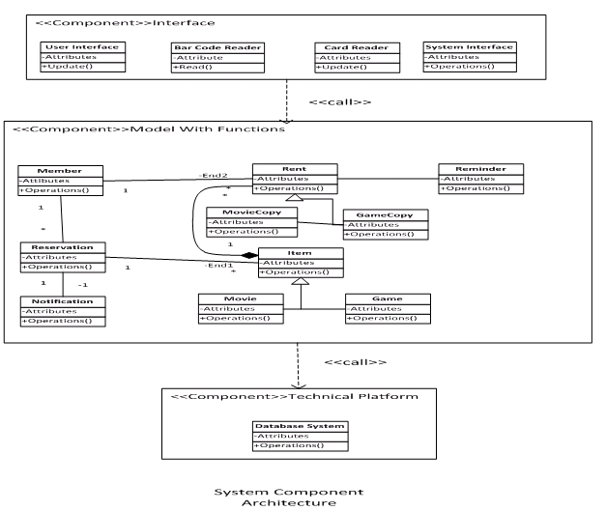
Figure 5 System Component Diagram
Figure 5 Depicts how components are wired together to form the software system

6.1 Model Component

Figure 3 you can see the model component. Our class structure required very little
changes, because all iterations as well as common events were already represented by
individual classes in the first model structure. Our efforts were therefore concentrated on representing the private events as attributes in the appropriate classes. The revise class diagram is shown below with the addition of private events represented as attributes.

6.2 Function Component

We decided to represent all functions as operations in specific classes. To help us
achieve this, we examine each system function and went ahead to specify the classes
that contains essential attributes and non trivial operation as describe in the following.

Class: Member

Purpose: Registering members into the system and provide employees with relevant
functions needed for perform work related tasks.
Attributes: memberID, name, address, phone, email, amount Owed
Operations: add member, edit member, delete member, show member, search member, getMember, Cal amountOwed

Class: Item

Purpose: A class storing all game and movie information
Attributes: title id, title, producer, number of copies, genre, No of copies, list of items IDs
Operations: create title, edit title, delete title, show title, search title, update title

Class: Reservation

Purpose: A class allowing members to reserve movies or games copies.
Attributes: reservation id,memberid, titleid, reservation date
Operations: create reservation, edit reservation, delete reservation, show reservation,
show availability of title, getTitle, update title, getMember.

Class: Rent

Purpose: A class allowing members to rent movie or game copies
Attributes: itemID, title ID, state, return date, amount of reminders, rental date,
Operations: Rental, rentalReturned, update Title, update Reminder, update Member, overdueRental, getTitle

Class: Reminder

Purpose: This class creates and sends reminders to members for each overdue rental Item.
Attributes: Reminder ID, NextSendDate, OverdueRental
Operations: Send reminder, CreateReminder, overdueRental, NextSendDate

Class: Notification

Purpose: Sends a notice to member when a reserved item becomes available
Attributes: reservationID, notificationDate
Operation: SendNotification, getReservation

6.3 Connecting Components

In connecting the components, the main consideration was to preserve the architecture’s layer pattern as well as achieve low coupling among components and high cohesion among classes. To ensure this was the case, we employed the operation call method for connecting components. This means that the interface layer will send operation calls to the model component when it requires access to the model and likewise the model component will call the technical platform component to gain access to the database system and network systems. This can be seen in figure 3 where the down wards arrows represent component dependencies. For example an interface in the interface component would call operation in the model component if it requires reading or updating. While the specific connection is not shown, it can be assumed that it could be any interface system shown in the interface component accessing a class shown in the model component to call/invoke an operation describes in the function component. The semantics of how the process could work can be seen in the follow sequence diagrams.

- Graphical User Interface (GUI)
The Graphical User Interface (GUI) is implemented with Java Swing components. We used Netbeans IDE to create the window format, as it has an easy drag-and-drop interface to create the display window. This GUI was created was the intention of making the use of the system an easy task for the employee. Any functionality the employee wishes to do are just a click awayas can be seen in Employee Login & Main Menu window which show the main menu page. First, the employee has to log in through the page shown below.

The page that follows is dependent on whether or not the employee is an administrator or just a normal employee. An administrator would refer to a manager or supervisor and anyone in higher ranks. As shown in the screenshots below the Administrator has more functionalities that only an administrative staff can perform. Illustration 2 shows the Main Menu window for a normal employee. These are the only functionalities these employees can handle.

Otherwise, if an administrator logs in, he/she would get this page.

In Illustration 3, you can see the fourextra functionalities that can only be done by an administrator.These are functionalities that include more dignified decision, such as “Suspend Privileges”, we would not want a new staff member, to be able to perform such actions, as they may be malicious, or may play pranks. Whereas someone in a higher position is believed to be a dilligent worker who will follow company policies and would only perform such an actions if the right criteria is met. The same goes for “Renew Membership”. “Add Item” and “Remove Item” should also be done by only an administrator, as these functions make permanent changes to the inventory of the video store, and we would not want this in the hands of just anyone, but only the dignified and authorized personnel. “Add Item” allows the administrator to add a new item (video or game) to the video store database and inventory. “Remove Item” allows for the administrator to remove an item(video or game) from the database and inventory. It can be seen in Employee's view Use Case Diagram , that only the Administrator, who is a subtype of Employee, has direct access to those use cases.
From the Figure 6: Employee Login, the employee can choose any of the displayed actions and the appropriate windows will be displayed, asking for whatever information that may be needed to be entered. Most of the actions require the member’s information, and so the system would prompt for the Membership card to be scanned. For now we simulate that action by just asking for the Member ID to be manually entered.
After the Membership card has been scanned and validated, the window corresponding to the button pushed is displayed. We discuss two possible operations selected below(Rent Item & Rent Item):

After the membership card has been scanned, if the”Rent Item” button was clicked, the employee can scan the barcode of the items to be rented. We simulate this with another prompting dialog shown in Figure 11: Scan Item Dialog except titled “Rent” instead. The database is then queried to get the title corresponding to that scanned item, which is then displayed as those 3 shown in Figure 10: Rent Item(with sample input)If the “Return Item” button was clicked, the employee can scan the items being returned. This is simulated with another prompting dialog shown in Figure 11: Scan Item Dialog. This confirms that it is fact from our video store and that the item is what it appears to be, by displaying the title as in Figure 12: Return Item(with sample input)
Create Account:

If the employee clicks the button, “Create Account”, Figure 13: Create Account window is opened. The employee then fills in the text fields with the appropriate information provided by the customer. The employee then clicks the “Enter” button when all fields are filled. The customer information is then inserted in the database, and then displayed in a new window as shown below in Figure 14: New Member Information Display.

After performing the actions, the customer has to pay for, and so most of these pages lead to the payment page shown below with sample data, this is how it would show in the case of a purchase or rent. The previously scanned items’ information is transferred and there the price is also displayed.

In the case of just paying without any scanned items, the scanned item list would simply be empty and the total would equal to the Member’s account balance.

There are still some actions to be added to the GUI. we need to implement a button to take one back to the Main menu window instead of having to close and enter login info again, when doing another action and/or working with another customer.

Data Dictionary

Implementation
The implementation of the online aspect of the Video Store System was done using a Database Driven Website using MySQL and PHP. “A database driven website allows the content of the site to reside in a database and for the content to be dynamically accessed to create web pages for users to view with a web browser.[1]”
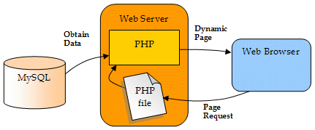[1]
Figure 8 illustrates how PHP and MySQL interact with a web server to display pages via a web browser.
As seen in Figure 8 above, PHP scripting language acts as a bridge, connecting the MySQL database and the Web Browser. PHP executes the page request, retrieves the necessary data from the MySQL database and dynamically produces a page which is in a format that the Web Browser can understand.
In the following sections we will discuss the use of a MySQL Database section 10.1 and PHP scripting language section 10.5 in the creation of our Database Drive Website for the VSS. We wee discuss the type of database used, the type of database management system used and how PHP was utilized to create scripts for querying the database for items and to create a login script to validate users and control access to the site.

Database Server
To store the system data we decided to use a database server implemented on a web server instead of creating a local file system to store the data. A database server was utilised due to the secure data accessing environment and since it is hosted on a web server that allows easier access from different locations (stores). If a local file system is used, we would need to build communication between all stores, an implementation which would prone to errors; this can also be very inefficient since terminals need to create connections to multiple store to get the information in every store. Database servers also provide security, allowing for restricted access to the data.
The only disadvantage of the database server implementation is that if the server ever crashes, all store terminals will not be able to function. This is a very serious problem. However this
may be resolved using a more reliable DBMS than MySQl for instance Oracle. But due to cost we opted for the open source MySQL.
In choosing a database management system (DBMS), we used the open source database management system MySQL 5. We chose MySQL over other open source database management systems such as PostgreSQl because it was more widely used, providing us with more tutorials.

A database management system allows us to easily:
- Create/delete tables
- Modify tables (adding, deleting, editing and rearranging records, changing the table structure)
- Retrieve data from a table or number of tables (finding and displaying an individual record, answering queries)

We used a Relational Database Management System, where the data is organised in tables and there are relationships expressed between tables and data elements. Relational databases work on the principle that each table has a key field (primary key) that uniquely identifies each row. These keys may be used to connect one table to another. For example a table (members) might a membersId as the primary key along with name, address and telephone number. The memberId in this table could be linked to another table in our case reservations that also includes memberId (a key) but, contains information about items the member has reserved.
Advantages of a Relational DBMS [3]:
- Easy to create and modify
- Efficient data retrieval and reporting
- Changes to the database schema are easy. In our project to create the Database Schema we used the database tools, Toad for MySQL 6 and MySQL Workbench 5.2.
- Java support (JDBC). Java Database Connectivity is an API for Java programming language. It defines how a client may access a database. JDBC provides methods for querying and modifying data in a database. JDBC is oriented towards relational database. [2]

Entity Relationship Design
Objects such as customers, members, items and store locations correspond to entities in the Entity-Relationship model and the operations performed on those entities: reservations, rentals correspond to the relationships. However, a good design will minimize redundancy and attempt to store all the required information in as small a space as possible.The structure of the database was shown graphically in and E-R Diagram below which consists of the following components [6]:
- Rectangles, which represent entity sets
- Ellipses, which represent attributes
- Diamonds which represent relationship sets
- Lines which link attributes to entity sets and entity sets to relationship sets.

Relational SQL Database Definition
We created six tables and populated them with sample data. Below is the following code to create the tables.

Database Schema
The Database Schema below in Figure 7 shows the relationships amont the various entries in the tables of the database..
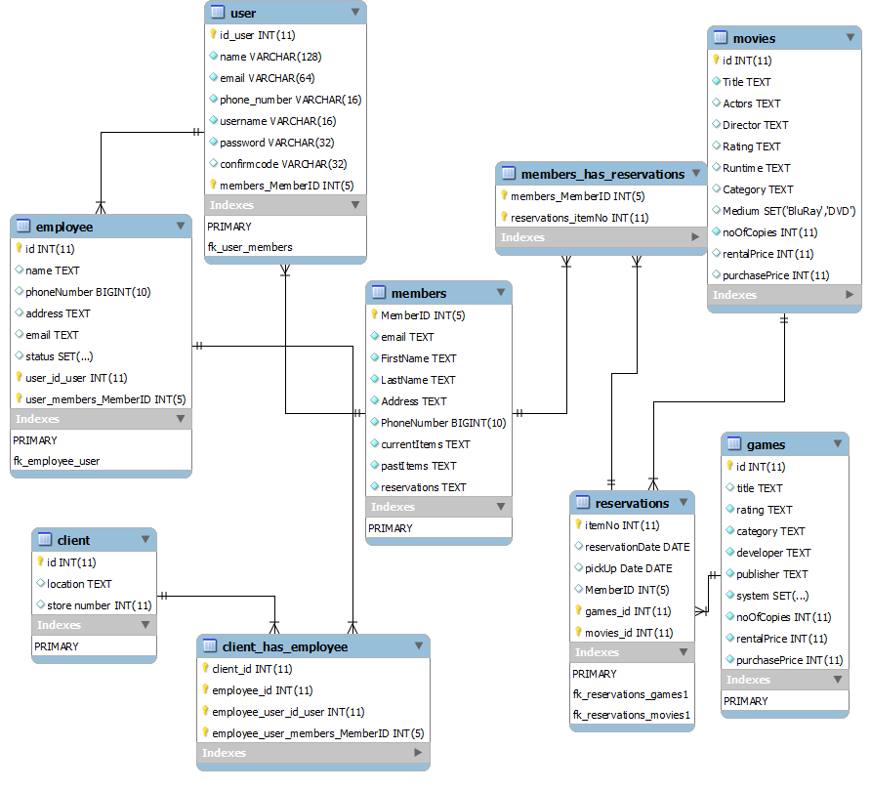
Figure 6 Show the Database Schema used by the Video Store System

PHP
We used PHP to embed dynamic text into static text. PHP is easily used with HTML forms making it useful for the web server application. PHP is compatible with our MySQL database, which allows PHP code to create and query the tables in the database. PHP is also cross platform compatible. Using PHP we can create and execute scripts which are similar to functions to execute actions which are done often. PHP scripts allow us to quickly execute actions without the need to re-enter code every time we want to complete that action. Example of PHP scripts used were a search script and a log in script, both are discussed later in this section. With PHP being a server side language, all the code execution is done on the server and the user never has to worry about it.
PHP is also very easy to learn and there are a wealth of tutorials available online, giving in depth details and support on the language.
To dynamically link the website queries to the database we used PHP to code the sections for login and search.
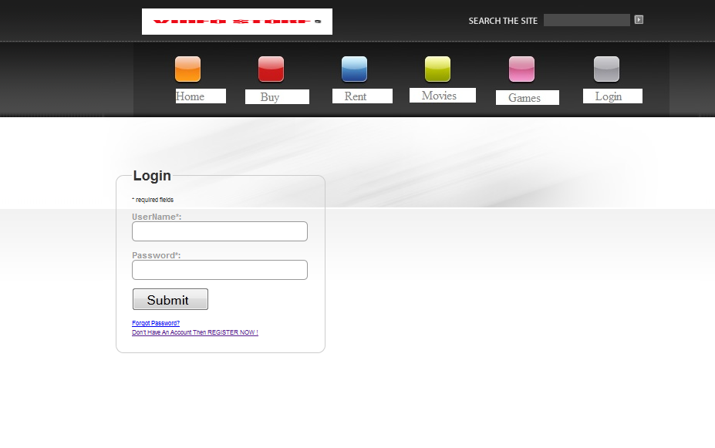
Figure 7 Login
From the Customers’ View Use Case diagram, we created the User Login use case. This use case was written in PHP and uses the excellent form validation script from JavaScript-coder.com.
On the Login web page page we also created the register panel which requests the user email to validate their account database - uses the excellent form validation script from JavaScript-coder.com. In the event the user has forgot their password, there is a forgot password case which prompts the user to enter the email they used when creating their account.
Code excerpts for the Login PHP script can be found in Appendix ( )
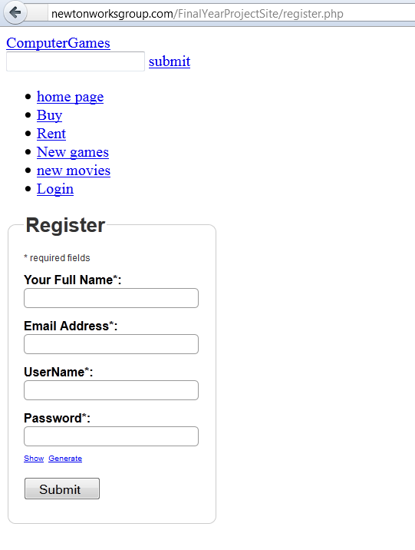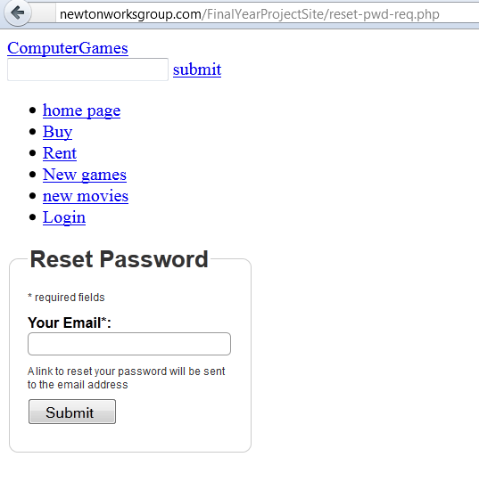
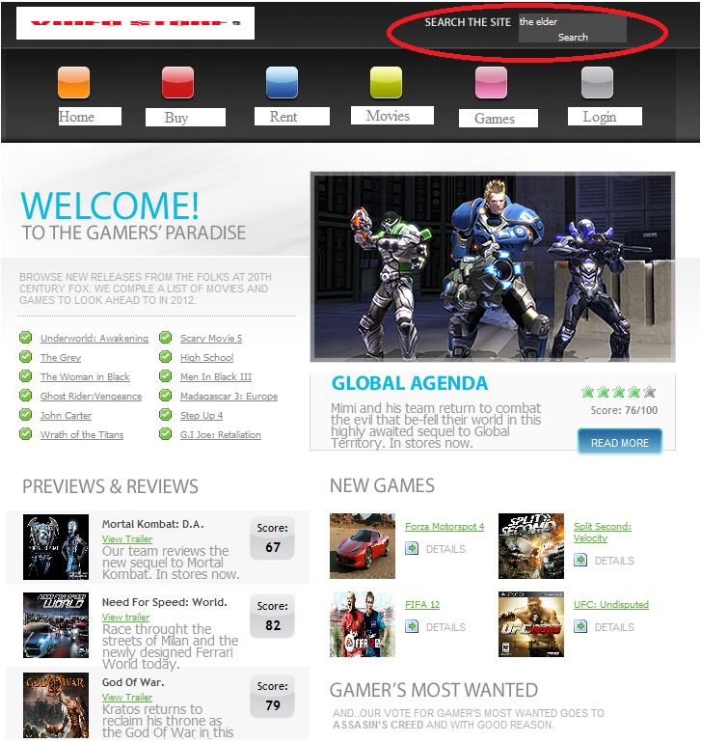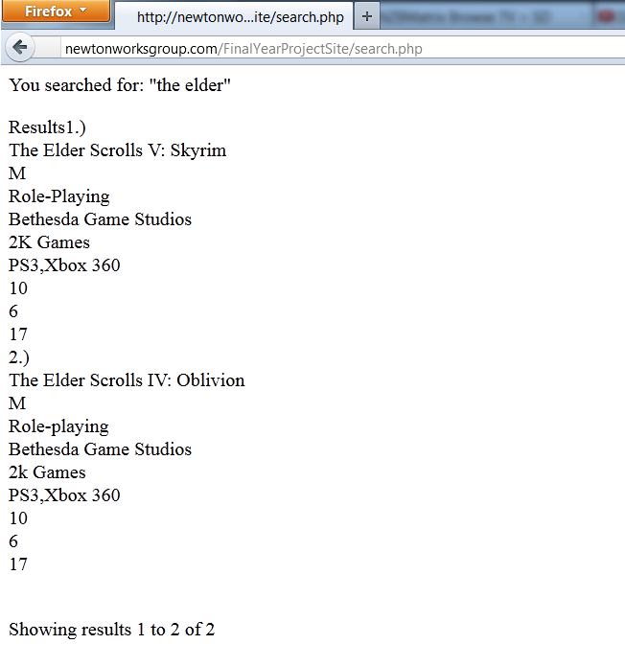
(a) Main webpage with “the elder” in search field (b) Results of search query
Figure 9 Main webpage with “the elder” in search field (a) and results search query (b) screenshots
Querying a MySQL Database with PHP

The reason for using PHP as an interface to MySQL is to format the results of SQL queries in a form visible in a web page. As long as you can log into your MySQL installation using your username and password, you can also do so from PHP. However, instead of using MySQL’s command line to enter instructions and view output, you will create query strings that are passed to MySQL. When MySQL returns its response, it will come as a data structure that PHP can recognize instead of the formatted output you see when you work on the command line. Further PHP commands can retrieve the data and format it for the web page.

The process of using MySQL with PHP is [8]:
1. Receive user input
The user has entered a string into the search field to be queried.

1. Connect to MySQL Server.
In the PHP search script the following code must be executed to connect to the MySQL database. We issue this connection command with the PHP function called mysql_connect( ). The variables used by the connect statement are
- Host name. In our case, it is the local host because we’ve installed everything locally to the web server.
- User name. user name that you’ll need to insert to access your specific server.
- User name’s password. Password needed to access database

//connect to your database
mysql_connect("localhost"," "," "); //(host, username, password)

2. Select the database to use.
Once a connection has been made to MySQL we must specify which database to connect to. We use the function msql_select_db(database name) to specify which data base to connect to.

//specify database to connect to
mysql_select_db("sourceit_VSS") or die("Unable to select database"); //select which database we're using

3. Query the database.
In Figure 9 (a) we query the database for “the elder” . To query the database the mysql qyery( ) funtion is utlizied. For our website the tables that can be queryed are movies and games. In other tables were to be accessed, they could be easilt added using the select statement along with the mysql qyery( ) function.

// Build SQL Query
$query = "select * from games where title like \"%$trimmed%\" "; // EDIT HERE and specify your table and field names for the SQL query
$gameresults=mysql_query($query);
$gamenumrows=mysql_num_rows($gameresults);
if($gamenumrows!=0){
$numresults=$gameresults;
}else{
$query = "select * from movies where title like \"%$trimmed%\" "; // EDIT HERE and specify your table and field names for the SQL query
$numresults=mysql_query($query);

5. Retrieve the results and output it to a web page.
Figure 9 (b) shows the results of the query for “the elder”. After the mysql qyery( ) function has been executed and the results stored in $result . The function mysql_fetch_array( ) returns an associative array. [9] The statement "$row = mysql_fetch_array()" is implemented as a while loop. This achieves two things [9]:
- We will get a new row of MySQL information that we can print out each time the while loop checks its conditional statement. In our example where we search for “the elder” . They were two results “The Elder Scrolls V: Skyrim” and “The Elder Scrolls IV: Oblivion”.
- When there are no more rows the function will return FALSE causing the while loop to stop.

// get results
$query .= " limit $s,$limit";
$result = mysql_query($query) or die("Couldn't execute query");

/ begin to show results set
echo "Results";
$count = 1 + $s ;

// now you can display the results returned
while ($row= mysql_fetch_array($result)) {

6. Disconnect from database (optional)
We did not include a disconnect statement but in the case that one was needed we would use mysql_close(database_connection).

To perform a search query on the database, the user must navigate to the search tab located on the top right hand corner of the main web page. The search tab allows the user to enter a string of text and query the database for entries matching the search criteria. In Figure 9 (a) we see an example of a query for “the elder” that was performed on the database, Figure 9 (b) shows the results of that query. From the results we see two matches to the query for “the elder” which are “The Elder Scrolls V: Skyrim” and “The Elder Scrolls IV: Oblivion”. In addition to returning the titles of items matching the search criteria, the search returning all the information located in the table for the matches. In our example the query returned the title, rating, category, developer, publisher, system, noOfCopies, rental price and sale price.

Website
“Video store” was originally designed to be a program that the company employees would interact with in order to execute functionalities such as rentals, sales, and account management to walk-in customers. However, after careful consideration and further research, the team decided that in order to improve customer satisfaction and keep up with the current standards in the video rental industry, a website was needed.
The website was created using the Adobe Dreamweaver CS5.5 web authoring and editing software. This is because it is easy to use, provides CSS and HTML support, and is very compatible with the PHP development environment (i.e. web server, PHP and database).
The website was designed with the customer in mind. Therefore, simplicity, quality and design were taken into account. We ensured that the primary functionalities of the system are laid out for the user and that the operations were a simple click away. Also, a “search” function is implemented on the website that allows for the user to easily query the database to find video or game items. In order to ensure the user account is easily managed, a “login” function is also implemented to provide security and enable members have access to their personal accounts.

Future Work
Left to be done are:
- sequence diagrams
- state charts
- entity relationship diagram (need correct CASE tool)
Conclusion
References
http://www.databasejournal.com/features/mysql/article.php/1402281/Build-Your-Own-Database-Driven-Website-Using-PHP--MySQL-Pt-4.htm [1] accessed March 4th 2012

http://www.oracle.com/technetwork/java/javase/jdbc/index.html [2]

http://www.deeptraining.com/litwin/dbdesign/FundamentalsOfRelationalDatabaseDesign.aspx [3]
Henry, K and Abraham, S (1988) Database System Concepts. US: McGraw Hill [6]
Welling, Luke and Thompson, Laura. Php and MySQL Web Development 2nd Edition. US; Sams Publishing 2003. Web accessed March 15th 2012 [8]

http://www.tizag.com/mysqlTutorial/mysqlfetcharray.php [9] accessed February 13th 2012
- Complete use case descriptions
Use Case Descriptions
Use case name: Rent Item (Online)
Primary actor: Member
Secondary Actors(s): Delivery system, Email system
Precondition: Member has logged into his/her account on the Video Store website
Basic flow
- Member selects item(s) to rent.
- The system queues items until Member clicks “DONE” button.
- The system checks the status of all selected items.
- If all items are in-stock, the system displays the pricing for renting each item and also the total.
- Member accepts fees.
- The system credits fees to the Member's account.
- The system sends list of items to be delivered to Member's address.
- Delivery system queues the order.
- Email system sends the Member the details of his/her order, including date for when delivery would be made, pricing details, and members account details as well.
Postcondition: Delivery system has confirmed receipt of list of items to be rented by Member, and prepares for delivery.
Specific Alternative flow
BFS #4
If one of the items selected is unavailable i.e. all copies are off the shelf,
- The system displays price to rent in-stock items and prompts Member of the option to reserve the unavailable item.
- If Member selects option to reserve item, the system INCLUDES USE CASE Reserve Item.
- Return to BFS #5.

BFS #4 (SAF #2)
If Member doesn't wish to reserve item,
- The system dequeues unavailable item.
- Calculates new balance without unavailable item.
- Returns to BFS #5.

Global Alternative flow

Use case name: Search Title
Primary actor: Customer
Secondary Actor(s): None
Precondition: Customer clicks on 'search' option on website
Basic flow

- Customer types in title of item.
- Customer selects whether video or videogame.
- Customer presses 'enter' key

Postcondition: The system displays all search results and gives options on what actions can be taken on each item.

Specific Alternative flow: None
Global Alternative flow: None

Use case name: Create account
Primary actor: Customer
Secondary Actor(s): Email system
Precondition: Customer does not have an account.
Basic flow
- The system asks for customer's information.
- Customer enters all requested information.
- The system VALIDATES all entered information.
- IF customer's information is valid, the system stores customer's information
- The system via Email System sends an email to the email entered by Customer, given the details the account and a temporary card for the Customer to print out.

Postcondition: Customer is a Member.

Specific Alternative flow
BFS #4
If customer's information is invalid,
- The system displays error message “Invalid <entry section>”
- Return to BFS #1

Global Alternative flow: None
Use case name: Cancel reservation
Primary actor: Member
Secondary Actors(s): Email system
Precondition: Member has an item reserved for him/her.
Basic flow
- Member clicks on item that has been reserved.
- The system displays items status and reservation details.
- Member clicks cancel reservation button.
- The system removes the reservation on the item.
- The system via the Email system sends an email to Member, confirming the cancellation of the reservation.

Postcondition: The item is no more on reserve for Member

Specific Alternative flow: None

Global Alternative flow: None
Employee side Use Case Diagram
Use case name: Rent Item (In-store)
Primary actor: Employee
Secondary Actors(s): Member, Barcode Scanner
Dependency: INCLUDES USE CASE Read Barcode
Precondition: Member has presented the Employee with an item(s) to rent.
Basic flow
- Employee requests Membership card.
- Employee scans membership card, INCLUDES USE CASE Read Barcode
- The system VALIDATES the Membership card
- If card is valid, the system returns the member's account information.
- Employee scans the item(s), INCLUDE USE CASE Read Barcode.
- The system returns the price(s) to rent video.
- The system adds item(s) to members account.
- The system returns a return date for rented item.

Postcondition: Item is ready for member to take home, after payment.

Specific Alternative flow
BFS #4
If the membership card is not valid,
- Then Employee does not allow Customer to rent the item(s).
- Employee gives Customer option of purchasing item(s).

Global Alternative flow: None
Use case name: Renew Membership
Primary actor: Employee
Secondary Actors(s): None
Precondition: Membership has reached expiry date
Basic flow
- The system prompts for membership card to be scanned.
- Employee scans membership card.
- The system displays account details and amount for renewal
- The system INCLUDES USE CASE Pay Dues

Postcondition: Membership card is made valid and expiry date is returned

Specific Alternative flow: None
Global Alternative flow: None
Use case name: Return Item
Primary actor: Employee
Secondary Actors(s): Barcode Scanner
Precondition: Employee obtains item(s) from Member
Basic flow
- Employee scans membership card.
- The system displays list of items the Member is yet to return.
- The system prompts the Employee to scan item(s)
- Employee scans item, and the system INCLUDES USE CASE Read Barcode
- The system matches the scanned item(s) with item(s) on the list of items that have not been returned.
- IF the scanned item matches with any of the items on the displayed list, the item is removed from the list of items not returned.

Postcondition: The system status the status of all returned items to “in-stock”

Specific Alternative flow
BFS #6
IF the scanned item does not match any item on the displayed list,
- The system displays message “ Item has already been returned ”
- Return to BFS #3
Use case name: Print Receipt

Primary actor: Printer
Secondary Actors(s): Employee
Dependency: INCLUDES USE CASE Purchase Item
Precondition: A Member purchases an item
Basic flow
- Member selects an item to purchase.
- Employee requests Membership card,
- Employee scans membership card, INCLUDES USE CASE Purchase Item
- The printer prints the receipt

Postcondition: The receipt for the item is printed

Use case name: Update Account Info
Primary actor: Administrator
Secondary Actors(s): DBMS
Precondition: Administrator must be connected to the database
Basic flow
- The Administrator searches the system for the customer account .
- The Administrator updates the required customer account information values.
- The system VALIDATES the entered customer Account information.
- The DBMS saves the changes made

Postcondition: The receipt for the item is printed

Use case name: Remove Item Title
Primary actor: Administrator
Secondary Actors(s): DBMS
Precondition: An item is no longer available by Video Store
Basic flow
- Administrator searches DBMS for item title
- Administrator removes item title from DBMS
- DBMS saves the changes

Postcondition: The item title is removed from DBMS

Use case name: Add Item Title
Primary actor: Administrator
Secondary Actors(s): DBMS
Precondition: An item is to be added to the Video Store
Basic flow
- Administrator adds item title from DBMS
- DBMS saves the changes

Postcondition: The item title is added to DBMS

Use case name: Read Barcode
Primary actor: Employee
Secondary Actors(s): Barcode Scanner
Dependency: INCLUDES USE CASE(S) Return Item, Purchase Item, Rent Item (in store)
Precondition: Employee obtains item(s) from Member
Basic flow
- Employee scans membership card.
- Employee scans item barcode.
- IF the Member is returning item(s) THEN Employee scans the item(s) barcode using Barcode Scanner
- INCLUDES USE CASE Return Item

Postcondition: The barcode of the item(s) is scanned

Specific Alternative flow

BFS #3
ELSE IF the Member is purchasing an item(s) THEN INCLUDE USE CASE Purchase Item
ELSE the Member is renting item(s) in-store INCLUDE USE CASE Rent Item (in store)

Postcondition: The barcode of the item(s) is scanned

Employee Side:

Use case name: Return Item
Primary actor: Employee
Secondary Actors(s): Member, bar code Scanner, calendar and clock system
Dependency: INCLUDES USE CASE Read Barcode.
EXTENDED BY USE CASE Item overdue.
Precondition: Member has presented the Employee with an item(s) to return.
Generalization: None

Basic flow
- Employee requests Membership card.
- Employee scans membership card, INCLUDES USE CASE Read Barcode
- The system VALIDATES the Membership card
- If card is valid, THEN the system returns the member's account information.
- Employee scans the item(s), INCLUDE USE CASE Read Barcode.
- EXTENDED BY USE CASE Item overdue.
- The system removes item(s) from members account.
- The Employee returns the item(s) back to shelf.

Postcondition: Item has been successfully returned.
Specific Alternative flow
BFS #4
If the membership card is not valid,
- Employee gives Customer an option of creating or renewing his/her membership.

Use case name: Purchase Item
Primary actor: Employee
Secondary Actors(s): Member, bar code Scanner, Printer
Dependency: INCLUDES USE CASE Print receipt.
INCLUDES USE CASE Read bar code
Precondition: Member or customers has presented the Employee with an item(s) to purchase.
Generalization: None
Basic flow
- Employee requests Membership card.
- Employee scans membership card, INCLUDES USE CASE Read Barcode
- The system VALIDATES the Membership card
- If the card is valid, THEN the system returns the member's account information.
- Employee scans the item(s), INCLUDE USE CASE Read Barcode.
- The system returns the price(s) of the item(s).
- The employee receives the items(s) payment from the member.
- INCLUDES USE CASE Print receipt.

Postcondition: Item has been successfully purchased.
Specific Alternative flow
BFS #4
If the membership card is not valid or available,
- Employee gives Customer an option of creating or renewing his/her membership.
ELSE
- Employee scans the item(s), INCLUDE USE CASE Read Barcode.
- The employee receives the items(s) payment from the customer.
- INCLUDES USE CASE Print receipt.
Use case name: Search title
Primary actor: Employee
Secondary Actors(s): None
Dependency: None.
Precondition: A Customer or a member asks about a specific title(s)
Generalization: None
Basic flow
- The system prompts the employee to enter the title name.
- The employee enters the title(s) name.
- The system VALIDATES if the title name is valid.
- IF the title name is valid, THEN the system returns the item(s) information.

Postcondition: The employee has successfully searched for the title(s).
Specific Alternative flow
BFS #3
If the title not valid,
- The System requests to re-enter title name.
ELSE
- The employee reports to the customer or member that the specified title is not available on the system.

Use case name: Create Account
Primary actor: Employee
Secondary Actors(s): Customer, Email System, Printer.
Dependency: INCLUDES USE CASE Print membership card.
Precondition: Customer requests that if he/she can create a Video store account.
Generalization: None
Basic flow
- The Employee enters the required customer account information values.
- The system VALIDATES the entered customer Account information.
- The system notifies the employee that the account has been created.
- INCLUDES USE CASE Print membership card.
- The system notifies the customer by email that his/her account has been created.

Postcondition: the account has been created.

Specific Alternative flow
BFS #4
If the account information is not valid,
- The system requests to re-enter the account information.

Use case name: Cancel Reservation
Primary actor: Employee
Secondary Actors(s): Bar code scanner.
Dependency: INCLUDES USE CASE Read bar code.
Precondition: Member requests that if he/she could cancel item reservation.
Generalization: None

Basic flow
- Employee requests Membership card.
- Employee scans membership card, INCLUDES USE CASE Read Barcode
- The system VALIDATES the Membership card.
- If the card is valid, THEN the system returns the member’s reservation detail.
- The employee clicks on cancel reservation button.
- The system removes the reservation on the item.

Postcondition: The reservation has been cancel.

Specific Alternative flow
BFS #4
If the membership card is not valid or available,
- Employee gives Customer an option of creating or renewing his/her membership.

Member Side:

Use case name: Reserve Item
Primary actor: Member
Secondary Actors(s): Email System.
Dependency: None.
Precondition: Member is authenticated
Generalization: None
Basic flow
- Member enters the item’s title.
- The system VALIDATES if the title is available.
- Member activates the reserve function.
- The system VALIDATES if the member has a reservation privileges.
- The system creates a pending reservation for that item.
- The system notifies the member by email that the item has been reserved.

Postcondition: an item has been reserved.
Specific Alternative flow
BFS #4 the title is not available.
- The system displays a message that the item is not available.

BFS #4 the member has not a reservation privilege.
- The reservation is cancelled.

1.2 Data Dictionary
Entity classes

Employee:

This class represents the employee inside the video store. He/she can rent, reserve, receive payment, and create a membership account for the customer.

Attributes:
id: int Employee unique identifier
name: String Name of the employee
phone: int Phone of the employee
address: String Address of the employee
email: String The email of the employee
password: String Password of the employee

Methods:
createMemeberAccount(): void
- This method adds a new member to the list of member.

Item:
This class represents an item in the video store.

Attributes:
title: String title of the item.
barCodeNo: int The bar code on the item
dateRented:Date The returned date of the item
reserved: boolean Is the item reserved or not?
purchasePrice: doube The price of the purchased item.
rentalPrice: double The price of the rented item
decription: String short description about the item
overdue: Boolean Is the item overdue?
pickUpDate: Date The pickup date of the item
inStock: Boolean Is the item available on stock?
waitingList<ArrayList>: Accountmember The list of members how are waiting for the
Reservation.

Methods:
getBarCode():int get the bar code of the item
getTitle(): String get the title of the item
checkStatus(): Status set the status (i.e. Rented, or reserved) of the item
getPrice: double get the price of the item
checkOverdue(): Boolean if the item is returned late, and overdue is applied, returns true.
getPickupDate():Date get the pickup date for the item if purchased online or reserved.
getReturnDate(): Date get the return date of the item
addCopy: void add a item copy to the list of items.
setReturnDate: void set the return date of the item if rented.
setPrices(): void set the price of the item.
setStatus(): void change the status of the item.
setPickUpDate: void set the pickup date for the item

Payment:
This class represents the payment information about a specific item.

Attributes:
isPaid: Boolean is the item paid for during the transaction.
index: int item index.
amount: BigDecimal amount paid for an item.
paymentDate: Date the date of the payment
paidItem[]: Item the list of paid items.
Methods:
getAmount(): BigDecimal returns amount paid for the item
getPaymentDate(): Date returns the date of the payment
getItemIndex(): int returns the item
getEmployee(): Employee return the employee how handled the payment.
isPaid(): boolean returns true if the payment made successfully.
getAccountMember(): AccountMeember returns the member who made the payment
getIndex(): int returns the payment Index (i.e. Id) of a specific item.
setPaidTrue(): void sets the payment condition to true if its false.

Cash Payment:
This class represents the cash payment of the item if the member or the customer chooses to pay in cash.

Attributes:
amountTendered: BigDecimal the amount of cash the customer or member is paying
Methods:
getAmountTendered(): amount returns amount of cash paid for.
setAmountTendered(): void sets the amount of cash to pay for.
clacChange(): void calculates the remaining change.

Video:
This class represents the video (DVD, CD, etc.) in the video store.
Attributes:
Genre: String the genre of the video.
Actors[]: String the actors of the video
Duration: int the duration or the length of the video.
videoType{ VHS, DVD, Blueray}: enum the type of the video.

Methods:
None for now.

Game:
This class represents the games in the video store

Attributes:
Console: String the console used to run the games, xbox, PS3 Wii, etc.
Genre: String the genre of the game
gameType{CD, DVD, Blueray} the type of the game.
Methods:
None for know.

Credit Card Payment:
This class represents the credit payment of the item if the member or the customer chooses to pay using a credit card.

Attributes:
Authorized: Boolean is the credit card authorized.
cardNumber: String the credit card number.

Methods:
getCardNumber(): int returns the credit card number
authorize(): Boolean checks if the card is authorized or not.

Reservation:
This class represents the reservation information o a specific item
Attributes:
ReservationId: int the reservation unique id.
collectionDate: Date the date that the member can collect the reserved item.
reservationDate: Date the date that item is available for reservation
isReserved: Boolean is the item available for reservation
item:Item the reserved item.

Methods:
getReservationStatus(): Boolean returns true if the item is on reserve.
getCollectionDate(): Date returns the collection date of the item.
getReservationDate(): Dare returns the reservation date the item.
getReservationID(): int returns the unique id of the reservation.
setCollectionDate: void sets the collection date for the reserved item.
setReservationDate: void sets the reservation date of the reserved item.
changeReservationStatus: void changes the reservation statues to reserved or not reserved.
getItem(): Item return the reserved item.

Account Member:
This class represents the account member of the video store.
Attributes:
Id: int a unique member identifier.
Name: String the name of the member
Balance: double the balance remaining on the member’s account
Phone: int the member’s phone number
Address: String the member’s address
Email: String the member’s email
Password: String the member’s password

Methods:
reserveItem(): void member reserves an item
rentItem(): void member rents an item
purchaseItem: void member purchases an item.

- Definitions, acronyms, abbreviations
Terms | Definition
Database (DB) | A collection of information organized in such a way that a computer program can quickly select desired pieces of data.
DBMS | Database Management Systems: a collection of applications that enables you to store, modify, an extract information from a database.
VSS | Video Store System, described in this document
SQL | Abbreviation of structured query language. Standardized query language for requesting information from a database.
MySQL | Software which is using SQL language and allows users to create databases. Available under Open Source license and commercial licenses.
PHP | Hypertext Preprocessor, an open source, server-side, HTML embedded scripting language used to create dynamic Web pages.
E-R | Entity Relationship Diagram; a graphical representation of entities and their relationships to each other.
HTML | HyperText Markup Language, the authoring language used to create documents on the World Wide Web.
CSS
Dreamweaver
CASE tool | Computer Aided Software Engineering Tools, class of software that automate many of the activities involved in various life cycle phases.
Java
NeatBeans IDE

- Code Excerpts
  - Code excerpt for login validation
- <?PHP
- require_once("./include/membersite_config.php");

- if(isset($_POST['submitted']))
- {
- if($fgmembersite->Login())
- {
  - $fgmembersite->RedirectToURL("login-home.php");
- }
- }

- ?>
- <!DOCTYPE html PUBLIC "-//W3C//DTD XHTML 1.0 Strict//EN" "http://www.w3.org/TR/xhtml1/DTD/xhtml1-strict.dtd">
- <html xmlns="http://www.w3.org/1999/xhtml" xml:lang="en-US" lang="en-US">
- <head>
  - <meta http-equiv='Content-Type' content='text/html; charset=utf-8'/>
  - <title>Group14 | Video Store | Login</title>
  - <link href="../css/styles.css" rel="stylesheet" type="text/css" />
  - <link rel="STYLESHEET" type="text/css" href="style/fg_membersite.css" />
  - <script type='text/javascript' src='scripts/gen_validatorv31.js'></script>

  - <style type="text/css">
  - .g {
    - font-weight: bold;
  - }
  - </style>
- </head>
- <body>
- <div id="container">
- <div id="header">
- <div id="logo"><a href="index.html"><img src="../images/video_logo.jpg" alt="ComputerGames" width="247" height="34" border="0" /></a></div>
- <div id="searchForm">
- <form action="" method="post" enctype="multipart/form-data" name="searchForm">
- <img src="../images/h_search.jpg" width="94" height="17" alt="" id="h_search" />

- <input name="searchField" type="text" />
- <a href="#"><img src="../images/btn_search.jpg" alt="submit" width="13" height="13" border="0" id="submit"/></a>

- </form>
- </div>
- <ul class="menu">
- <li class="home"><a href="../index.html" title="home page">home page</a></li>
- <li class="previews"><a href="../buy.html" title="Buy">Buy</a></li>
- <li class="reviews"><a href="../rent.html" title="Rent">Rent</a></li>
- <li class="new"><a href="../movies.html" title="new movies">New games</a></li>
- <li class="top"><a href="../games.html" title="new games">new movies</a></li>
- <li class="contacts"><a href="../login/login.php" title="Login">Login</a></li>
- </ul>
- </div>

- <div class="center_content_pages">

- <div class="financial-application-form">
- <!-- Form Code Start -->
- <div id='fg_membersite'>
- <form id='login' action='<?php echo $fgmembersite->GetSelfScript(); ?>' method='post' accept-charset='UTF-8'>
- <fieldset >
- <legend>Login</legend>

- <input type='hidden' name='submitted' id='submitted' value='1'/>

- <div class='short_explanation'>* required fields</div>

- <div><span class='error'><?php echo $fgmembersite->GetErrorMessage(); ?></span></div>
- <div class='container'>
- <label for='username' >UserName*:</label><br/>
- <input type='text' name='username' id='username' value='<?php echo $fgmembersite->SafeDisplay('username') ?>' maxlength="50" /><br/>
- <span id='login_username_errorloc' class='error'></span>
- </div>
- <div class='container'>
- <label for='password' >Password*:</label><br/>
- <input type='password' name='password' id='password' maxlength="50" /><br/>
- <span id='login_password_errorloc' class='error'></span>
- </div>

- <div class='container'>
- <input type='submit' name='Submit' value='Submit' />
- </div>
- <div class='short_explanation'><a href='reset-pwd-req.php'>Forgot Password?</a></div>
- <div class='short_explanation'><a href='register.php'>Don't Have An Account Then REGISTER NOW !</a></div>
- </fieldset>
- </form>
- <!-- client-side Form Validations:
- Uses the excellent form validation script from JavaScript-coder.com-->

- <script type='text/javascript'>// <![CDATA[

- var frmvalidator = new Validator("login");
- frmvalidator.EnableOnPageErrorDisplay();
- frmvalidator.EnableMsgsTogether();

- frmvalidator.addValidation("username","req","Please provide your username");

- frmvalidator.addValidation("password","req","Please provide the password");

- // ]]>
- </script>
- </div>
- </div>

- <div class="clear"></div>
- </div>
- </body>
- </html>
  - Code excerpt for register
- <?PHP
- require_once("./include/membersite_config.php");

- if(isset($_POST['submitted']))
- {
- if($fgmembersite->RegisterUser())
- {
  - $fgmembersite->RedirectToURL("thank-you.html");
- }
- }

- ?>
- <!DOCTYPE html PUBLIC "-//W3C//DTD XHTML 1.0 Strict//EN" "http://www.w3.org/TR/xhtml1/DTD/xhtml1-strict.dtd">
- <html xmlns="http://www.w3.org/1999/xhtml" xml:lang="en-US" lang="en-US">
- <head>
- <meta http-equiv='Content-Type' content='text/html; charset=utf-8'/>
- <title>Register Area</title>
    - <link href="../css/styles.css" rel="stylesheet" type="text/css" />
- <link rel="STYLESHEET" type="text/css" href="style/fg_membersite.css" />
- <script type='text/javascript' src='scripts/gen_validatorv31.js'></script>
- <link rel="STYLESHEET" type="text/css" href="style/pwdwidget.css" />
- <script src="scripts/pwdwidget.js" type="text/javascript"></script>
- <style type="text/css">
  - .g {
    - font-weight: bold;
  - }
  - </style>
- </head>
- <body>
- <div id="container">
- <div id="header">
- <div id="logo"><a href="index.html"><img src="../images/video_logo.jpg" alt="ComputerGames" width="247" height="34" border="0" /></a></div>
- <div id="searchForm">
- <form action="" method="post" enctype="multipart/form-data" name="searchForm">
- <img src="../images/h_search.jpg" width="94" height="17" alt="" id="h_search" />

- <input name="searchField" type="text" />
- <a href="#"><img src="../images/btn_search.jpg" alt="submit" width="13" height="13" border="0" id="submit"/></a>

- </form>
- </div>
- <ul class="menu">
- <li class="home"><a href="../index.html" title="home page">home page</a></li>
- <li class="previews"><a href="../buy.html" title="Buy">Buy</a></li>
- <li class="reviews"><a href="../rent.html" title="Rent">Rent</a></li>
- <li class="new"><a href="../movies.html" title="new movies">New games</a></li>
- <li class="top"><a href="../games.html" title="new games">new movies</a></li>
- <li class="contacts"><a href="../login/login.php" title="Login">Login</a></li>
- </ul>
- </div>

- <div class="center_content_pages">

<div class="financial-application-form">

- <!-- Form Code Start -->
- <div id='fg_membersite'>
- <form id='register' action='<?php echo $fgmembersite->GetSelfScript(); ?>' method='post' accept-charset='UTF-8'>
- <fieldset >
- <legend>Register</legend>

- <input type='hidden' name='submitted' id='submitted' value='1'/>

- <div class='short_explanation'>* required fields</div>
- <input type='text' class='spmhidip' name='<?php echo $fgmembersite->GetSpamTrapInputName(); ?>' />

- <div><span class='error'><?php echo $fgmembersite->GetErrorMessage(); ?></span></div>
- <div class='container'>
- <label for='name' >Your Full Name*: </label><br/>
- <input type='text' name='name' id='name' value='<?php echo $fgmembersite->SafeDisplay('name') ?>' maxlength="50" /><br/>
- <span id='register_name_errorloc' class='error'></span>
- </div>
- <div class='container'>
- <label for='email' >Email Address*:</label><br/>
- <input type='text' name='email' id='email' value='<?php echo $fgmembersite->SafeDisplay('email') ?>' maxlength="50" /><br/>
- <span id='register_email_errorloc' class='error'></span>
- </div>
- <div class='container'>
- <label for='username' >UserName*:</label><br/>
- <input type='text' name='username' id='username' value='<?php echo $fgmembersite->SafeDisplay('username') ?>' maxlength="50" /><br/>
- <span id='register_username_errorloc' class='error'></span>
- </div>
- <div class='container' style='height:80px;'>
- <label for='password' >Password*:</label><br/>
- <div class='pwdwidgetdiv' id='thepwddiv' ></div>
- <noscript>
- <input type='password' name='password' id='password' maxlength="50" />
- </noscript>
- <div id='register_password_errorloc' class='error' style='clear:both'></div>
- </div>

- <div class='container'>
- <input type='submit' name='Submit' value='Submit' />
- </div>

- </fieldset>
- </form>
- <!-- client-side Form Validations:
- Uses the excellent form validation script from JavaScript-coder.com-->

- <script type='text/javascript'>
- // <![CDATA[
- var pwdwidget = new PasswordWidget('thepwddiv','password');
- pwdwidget.MakePWDWidget();

- var frmvalidator = new Validator("register");
- frmvalidator.EnableOnPageErrorDisplay();
- frmvalidator.EnableMsgsTogether();
- frmvalidator.addValidation("name","req","Please provide your name");

- frmvalidator.addValidation("email","req","Please provide your email address");

- frmvalidator.addValidation("email","email","Please provide a valid email address");

- frmvalidator.addValidation("username","req","Please provide a username");

- frmvalidator.addValidation("password","req","Please provide a password");

- // ]]>
- </script>
- </div></div></div>
- </body>
- </html>

  - Code excerpt for forgot password
- <?PHP
- require_once("./include/membersite_config.php");

- $success = false;
- if($fgmembersite->ResetPassword())
- {
- $success=true;
- }

- ?>
- <!DOCTYPE html PUBLIC "-//W3C//DTD XHTML 1.0 Strict//EN" "http://www.w3.org/TR/xhtml1/DTD/xhtml1-strict.dtd">
- <html xmlns="http://www.w3.org/1999/xhtml" xml:lang="en-US" lang="en-US">
- <head>
- <meta http-equiv='Content-Type' content='text/html; charset=utf-8'/>
- <title>Reset Password</title>
- <link rel="STYLESHEET" type="text/css" href="style/fg_membersite.css" />
- <script type='text/javascript' src='scripts/gen_validatorv31.js'></script>
    - <link href="../css/styles.css" rel="stylesheet" type="text/css" />
  - <style type="text/css">
  - .g {
    - font-weight: bold;
  - }
  - </style>
- </head>
- <body>
- <div id="container">
- <div id="header">
- <div id="logo"><a href="index.html"><img src="../images/video_logo.jpg" alt="ComputerGames" width="247" height="34" border="0" /></a></div>
- <div id="searchForm">
- <form action="" method="post" enctype="multipart/form-data" name="searchForm">
- <img src="../images/h_search.jpg" width="94" height="17" alt="" id="h_search" />

- <input name="searchField" type="text" />
- <a href="#"><img src="../images/btn_search.jpg" alt="submit" width="13" height="13" border="0" id="submit"/></a>

- </form>
- </div>
- <ul class="menu">
- <li class="home"><a href="../index.html" title="home page">home page</a></li>
- <li class="previews"><a href="../buy.html" title="Buy">Buy</a></li>
- <li class="reviews"><a href="../rent.html" title="Rent">Rent</a></li>
- <li class="new"><a href="../movies.html" title="new movies">New games</a></li>
- <li class="top"><a href="../games.html" title="new games">new movies</a></li>
- <li class="contacts"><a href="../login/login.php" title="Login">Login</a></li>
- </ul>
- </div>

- <div class="center_content_pages">
- <div id='fg_membersite_content'>
- <?php
- if($success){
- ?>
- <h2>Password is Reset Successfully</h2>
- Your new password is sent to your email address.
- <?php
- }else{
- ?>
- <h2>Error</h2>
- <span class='error'><?php echo $fgmembersite->GetErrorMessage(); ?></span>
- <?php
- }
- ?>
- </div>
  - <div class="clear"></div>
- </div>
- </body>
- </html>

  - Code excerpt for search
- <?php

- // Get the search variable from URL

- $var = $_POST['searchField'] ;
- $trimmed = trim($var); //trim whitespace from the stored variable

- // rows to return
- $limit=10;

- // check for an empty string and display a message.
- if ($trimmed == "")
- {
- echo "<p>Please enter a search...</p>";
- exit;
- }

- // check for a search parameter
- if (!isset($var))
- {
- echo "<p>We dont seem to have a search parameter!</p>";
- exit;
- }

- //connect to your database ** EDIT REQUIRED HERE **
- mysql_connect("localhost","sourceit","Kerrie69!@"); //(host, username, password)

- //specify database ** EDIT REQUIRED HERE **
- mysql_select_db("sourceit_VSS") or die("Unable to select database"); //select which database we're using

- // Build SQL Query
- $query = "select * from games where title like \"%$trimmed%\" "; // EDIT HERE and specify your table and field names for the SQL query
- $gameresults=mysql_query($query);
- $gamenumrows=mysql_num_rows($gameresults);
- if($gamenumrows!=0){
- $numresults=$gameresults;
- }
- else{
- $query = "select * from movies where title like \"%$trimmed%\" "; // EDIT HERE and specify your table and field names for the SQL query
- $numresults=mysql_query($query);
- }

- $numrows=mysql_num_rows($numresults);

- // If we have no results, offer a google search as an alternative

- if ($numrows == 0)
- {

- echo $gameresults;

- echo "<h4>Results</h4>";
- echo "<p>Sorry, your search: &quot;" . $trimmed . "&quot; returned zero results</p>";

- // google
- echo "<p><a href=\"http://www.google.com/search?q="
- . $trimmed . "\" target=\"_blank\" title=\"Look up
- " . $trimmed . " on Google\">Click here</a> to try the
- search on google</p>";
- }

- // next determine if s has been passed to script, if not use 0
- if (empty($s)) {
- $s=0;
- }

- // get results
- $query .= " limit $s,$limit";
- $result = mysql_query($query) or die("Couldn't execute query");

- // display what the person searched for
- echo "<p>You searched for: &quot;" . $var . "&quot;</p>";

- // begin to show results set
- echo "Results";
- $count = 1 + $s ;

- // now you can display the results returned
- while ($row= mysql_fetch_array($result)) {

- echo "$count.)&nbsp;"."<br>" ;

- if($row["title"]==""){ echo $row["Title"]."<br>";} else{ echo $row["title"]."<br>";}
- if($row["rating"]==""){ echo $row["Actors"]."<br>";} else{ echo $row["rating"]."<br>";}
- if($row["category"]==""){ echo $row["Director"]."<br>";} else{ echo $row["category"]."<br>";}
- if($row["developer"]==""){ echo $row["Rating"]."<br>";} else{ echo $row["developer"]."<br>";}
- if($row["publisher"]==""){ echo $row["Runtime"]."<br>";} else{ echo $row["publisher"]."<br>";}
- if($row["system"]==""){ echo $row["Category"]."<br>";} else{ echo $row["system"]."<br>";}
- if($row["Medium"]!=""){ echo $row["Medium"]."<br>";}
- echo $row["noOfCopies"]."<br>";
- echo $row["rentalPrice"]."<br>";
- echo $row["purchasePrice"]."<br>";
- $count++ ;
- }

- $currPage = (($s/$limit) + 1);

- //break before paging
- echo "<br />";

- // next we need to do the links to other results
- if ($s>=1) { // bypass PREV link if s is 0
- $prevs=($s-$limit);
- print "&nbsp;<a href=\"$PHP_SELF?s=$prevs&q=$var\">&lt;&lt;
- Prev 10</a>&nbsp&nbsp;";
- }

- // calculate number of pages needing links
- $pages=intval($numrows/$limit);

- // $pages now contains int of pages needed unless there is a remainder from division

- if ($numrows%$limit) {
- // has remainder so add one page
- $pages++;
- }

- // check to see if last page
- if (!((($s+$limit)/$limit)==$pages) && $pages!=1) {

- // not last page so give NEXT link
- $news=$s+$limit;

- echo "&nbsp;<a href=\"$PHP_SELF?s=$news&q=$var\">Next 10 &gt;&gt;</a>";
- }

- $a = $s + ($limit) ;
- if ($a > $numrows) { $a = $numrows ; }
- $b = $s + 1 ;
- echo "<p>Showing results $b to $a of $numrows</p>";

- ?>

